Roll no: 241701021

Computer Networks Exercise 3

Aim:
To connect two Switches through copper cross over and connect end devices with hub.

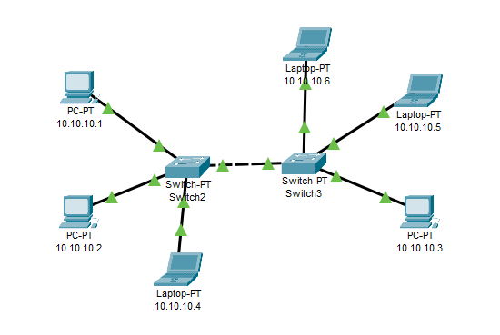
Components Required:
- 2 Switch
- 3 Desktop
- 3 Laptop
- 1 Copper cross over
- 5 Copper straight through
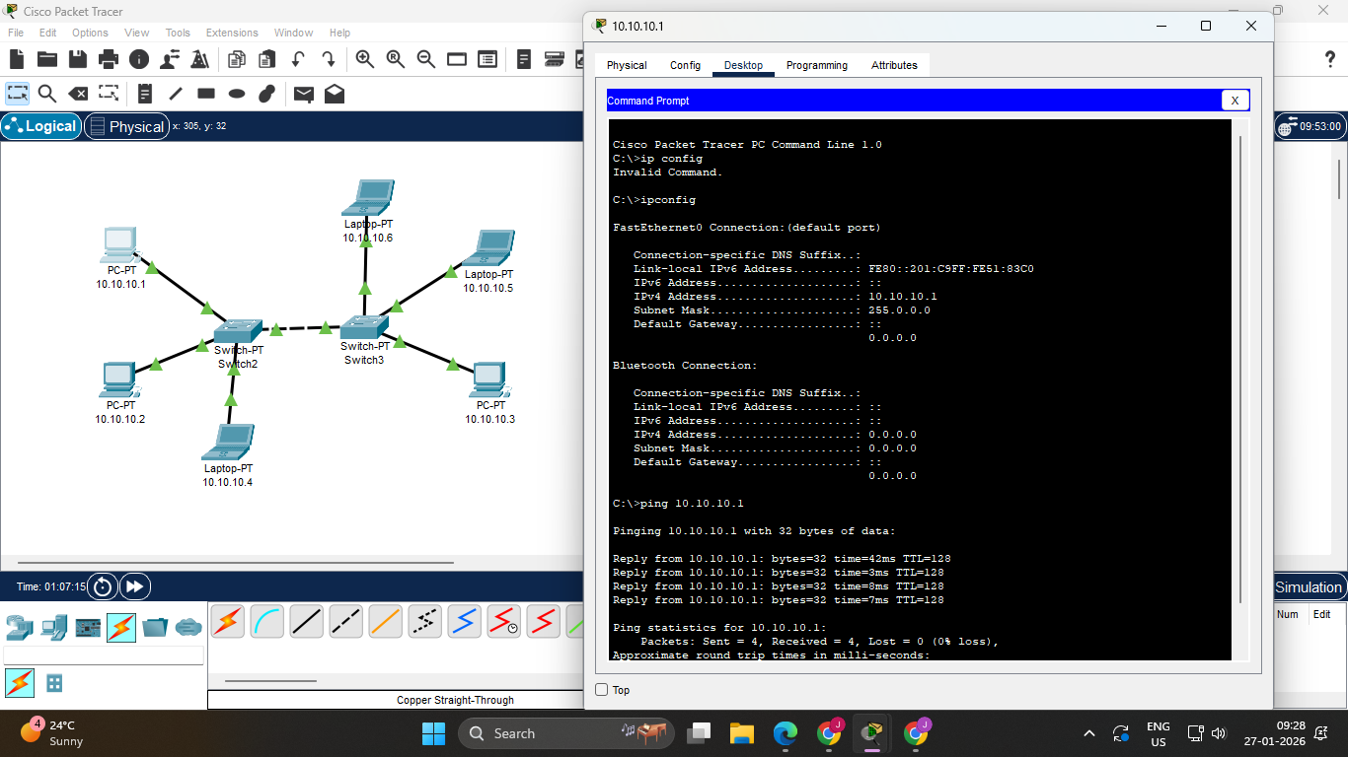
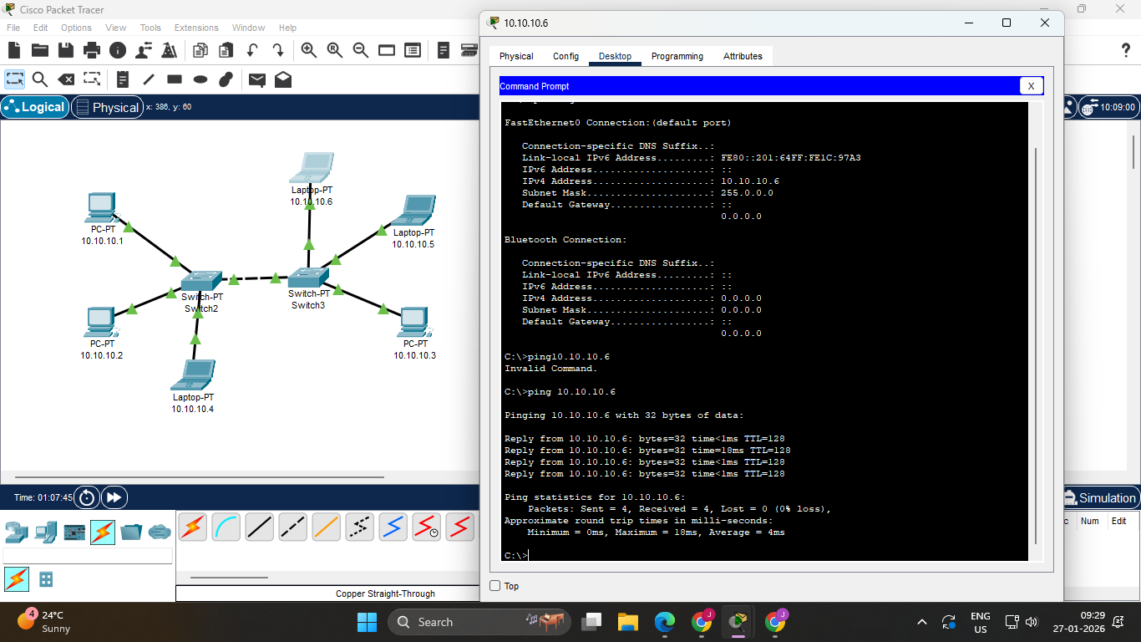
Procedure:

- Place the 2 PT Switch in the middle of the screen from the components provided.
- Place 6 End Devices around the PT Switch. It may be either a PC or a Laptop.
- Connect the 2 PT Switches through Copper cross over.
- Connect the End Devices to the PT Switch using Copper Straight-Through wires through Fast Ethernet.
- Click on each of the End Devices, go to Desktop and set the respective IP addresses in the IPv4 address tab.
- Rename the End Devices as per their respective IP addresses.
- Now, we can click on any End Device, go to Command Prompt in the Desktop tab and type in commands to view the ip configuration, to ping, etc.

Question:
- What is the difference between Switch and Hub?
Depending on the size and the efficiency of the network, hubs and switches are two important devices which assist in communication but the functionality is different. While hubs are easy to implement and inexpensive for small scale Networks, they are ineffective because of broadcasting. On the other hand, switches are more efficient and scalable than hubs and better for imparting large networks that bear a higher traffic rate. The basic factor that differentiates between a hub and a switch is size of the network, the management of traffic and the cost.

Result:
Thus connection two Switches through copper cross over and connect end devices with hub has been executed successfully.

